8/9/2018

Arik Stewart

Dominion Energy

Version: 1.0.0

Circle for Safety Simulation

Design Document and Instructions

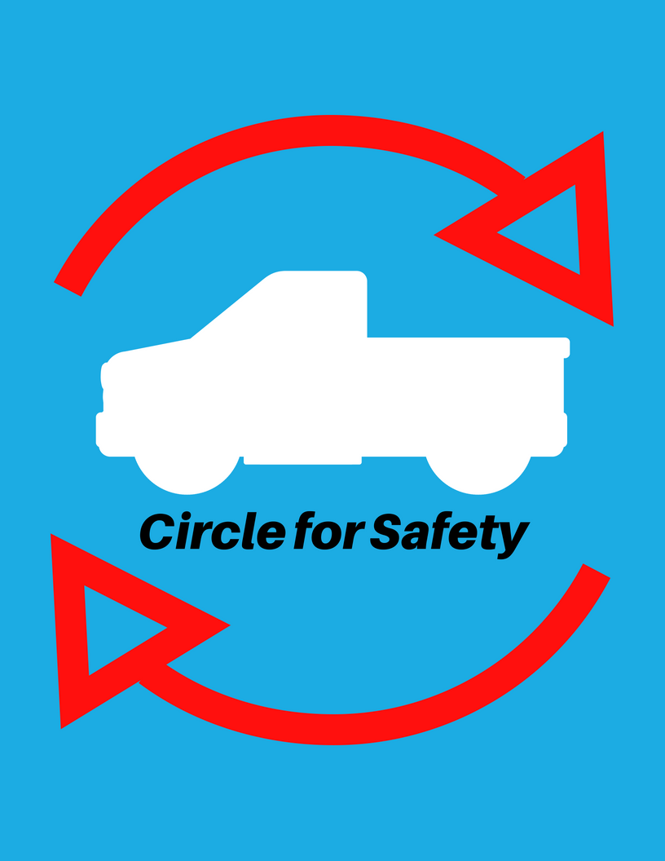

Training Simulation: Circle for Safety

Game Design Document

The following document will cover the concept and design for *Circle for Safety,* one of three Safe Driving Simulations created for Dominion Energy Employees.

**Author/Designer:** Arik Stewart—Commercial Operations Intern, Dominion Energy Ohio

Contents

**Overview** 2

Concept 2

Target Audience 2

Learning Objectives 2

Platforms/Minimum Specifications 2

Art Style 2

Software Used 3

**Instructions & Walkthrough** 3

Directions 3

Start-Up Instructions 3

Controls 3

General Controls 3

Default Controls 4

Free-Mouse Controls 4

Keyboard-Only Controls 4

Potential Hazards 4

Completion Instructions 5

Troubleshooting and Reporting 5

Arik Stewart – Developer/Designer, Commercial Operations Intern 5

Jennifer Slusser – AWTI Project Manager 5

Carrie Fanelly – General Manager Commercial Operations 6

**Overview**

## Concept

The simulation, one of three components that focus on safe driving practices, will place the player into a first-person environment in which they must learn and practice the company’s Circle for Safety procedure prior to operating a company vehicle. While the game environment focuses on safe practices from the perspective of a field employee, the procedures themselves are general enough to be applicable to all employees.

*Circle for Safety*—A procedure in which all employees must follow prior to entering their vehicle. The player will have to “circle”, or do a full 360⸰ walk around their vehicle while identifying and removing any hazards or risks to the safety of themselves or others while driving. Progress will be measured by the percentage of the vehicle that has been circled and the number of hazards left remaining on the scene.

## Target Audience

This application is targeted towards Dominion Energy employees that will be operating any motor vehicle. It will also serve the prime audience of employees that operate company vehicles, including large commercial vehicles. The general safety procedures that will be covered is applicable to any vehicle or environment.

## Learning Objectives

In this application, the employee will learn…

* The definition and purpose of a Circle for Safety procedure.
* When a Circle for Safety should be completed.
* How to successfully complete a Circle for Safety including:
  + Properly circling a vehicle for complete inspection.
  + The types of potential hazards that require attention.

## Platforms/Minimum Specifications

The Circle for Safety simulation was made as a web browser application. Target platforms and minimum specifications required for the application include the following:

* PC – Windows 7 Operating System
* ToughBooks & Toughpads – Windows 7 Operating System
* Internet Browser – Mozilla Firefox
  + Internet Explorer (May cause issues. Content may be blocked.)
* Mouse (Optional)
* Keyboard (Required)

## Art Style

Simple 3D art styles will be used with a few cartoonish models included for the depiction of bystanders within the scene. Since the perspective is third person, the player’s model will not be visible. Most 3D models have been acquired from the Unity Asset Store or through online websites under the creative commons license.

## Software Used

The following software has been utilized for the creation of this application:

* [Unity 3D Engine](https://unity3d.com/)—Version 5.6.1
  + [Visual Studio Community Component](https://www.visualstudio.com/vs/unity-tools/) — [C# Language](https://docs.microsoft.com/en-us/dotnet/csharp/)
* [Blender Studio](https://www.blender.org/)—Version 2.79b

**Instructions & Walkthrough**

## Directions

Do a complete circle around the company vehicle and remove any hazards in the area. Both a full circle must be completed and all hazards must be removed before entering the vehicle.

## Start-Up Instructions

The Circle for Safety simulation is made to run inside of any optimized web browser using Unity’s Web GL framework. To open the application:

1. Find the project files in its designated address in the company’s shared drive.
2. In the root folder, click on the web link titled “index”.
3. The link will automatically open up the webpage for the simulation, and the Unity web player will begin loading. (Don’t be alarmed if this takes a little time)
   1. Internet Explorer may give issues due to content being blocked by security. Make sure to open with Firefox for best results.
   2. If Firefox gives a memory error (i.e. “Couldn’t allocate memory), then close the browser and reopen it for the problem to go away. Make sure that no other tabs are opened. (This is planned to be addressed in future patches.)
4. To enable full screen, click on the designated icon in the bottom right of the web player.
5. While playing the game, you may get a message in the bottom of the browser asking permission for the application to lock/hide your mouse cursor. Make sure to grant that permission so that the game will work properly.
6. You will be presented with the main menu of the application. Choose the ‘Start” option to proceed.
7. After a brief loading screen, the instructions menu will appear and tell you how to play the simulation.

## Controls

The application utilizes three different control types that can be changed at any time via the in-game pause menu. The controls are as followed:

### General Controls

Standard controls that stay the same through any setting.

|  |  |
| --- | --- |
| Pause Game | “Shift” Key |
| Move Forward | “W” or “Up Arrow” Key |
| Move Backward | “S” or “Down Arrow” Key |

### Default Controls

Default controls using mouse and keyboard with free-look motion.

|  |  |
| --- | --- |
| Move Left | “A” or “Left Arrow” Key |
| Move Right | “D” or “Right Arrow” Key |
| Look Around / Move Camera | Mouse |
| Select / Remove Hazards | Left Mouse Button |

### Free-Mouse Controls

A variation of the default controls that separates movement from the mouse.

|  |  |
| --- | --- |
| Turn Left | “A” or “Left Arrow” Key |
| Turn Right | “D” or “Right Arrow” Key |
| Move Cursor (Now Visible) | Mouse |
| Select/Remove Hazards | Left Mouse Button |

### Keyboard-Only Controls

A variation of the Free-Mouse controls that utilizes only the keyboard.

|  |  |
| --- | --- |
| Turn Left | “A” or “Left Arrow” Key |
| Turn Right | “D” or “Right Arrow” Key |
| Select/Remove Hazards | “Space” Key |

## Potential Hazards

The following hazards can be found (Locations are randomly generated).

* Branch (Removable)
* Child (Special Removal)
* Street Lamp (Identifiable)
* Cone (Movable)
* Toolbox (Movable)

If *Removable*, the object will completely disappear after briefly glowing.  
If *Special Removal*, the object will complete a special action that will render it no longer a hazard.  
If *Movable,* the object will glow and then be moved to its proper location where it will be considered no longer a hazard.  
If *Identifiable,* the object is stationary and will remain in place, yet will glow to signal that it has been identified. The player will take a mental note so that it is no longer a hazard.

*Note:* For the best results, first-time players should not be made aware of the hazards that exist within the scene. Part of the goal is for the player to not only know how to successfully complete a circle for safety, but to also know what type of hazards to look for when doing the procedure.

## Completion Instructions

Welcome to Dom-City! You have now learned the controls and are ready to begin your Circle for Safety.

1. To unlock your truck, you must do the following:
   1. Reach 100% of “Circle Completion” by walking around your truck.   
      (Indicated in top-right corner of screen)
   2. Reach “All Hazards Completed” by removing/identifying every hazard in the scene.  
      (Indicated in top-left corner of screen)
2. Hazards can only be removed by standing within a certain distance of them. Approach and select them to prompt the confirmation screen. If you’re sure that it is a hazard, then click the confirm button to remove/identify the object.
3. When both objectives are completed, you will be prompted by a small pop-up that it is safe to enter your vehicle.
4. Following the prompt, approach the driver seat of your vehicle.
5. When in range, a small prompt will notify you that you may “Right Click” or hit the right mouse button to enter. This will end the simulation.
6. Congratulations! You will be presented with a screen that allows you to replay the simulation or exit back to the main menu.
   1. Note: If you choose to “Try Again” then the controls may revert back to the default setting. If they were changed before, then you will need to change them again. If control changes give issues, refresh your browser.

# Troubleshooting and Reporting

For troubleshooting or reporting any issues or bugs, please contact the following:

## Arik Stewart – Developer/Designer, Commercial Operations Intern

216-551-5406 [Arik.M.Stewart@dominionenergy.com](mailto:Arik.M.Stewart@dominionenergy.com)

## Jennifer Slusser – AWTI Project Manager

330-604-9246 [Jennifer.R.Slusser@dominionenergy.com](mailto:Jennifer.R.Slusser@dominionenergy.com)

## Carrie Fanelly – General Manager Commercial Operations

216-780-9062 [Carrie.F.Fanelly@dominionenergy.com](mailto:Carrie.F.Fanelly@dominionenergy.com)